Task No # 1: Create a temperature converter using JavaScript. Then apply a formula to convert Fahrenheit to Celsius.
Formula:
- Celsius = (Fahrenheit -32) * 5 / 9;

Solution:
<!DOCTYPE html>
<html lang="en">
<head>
<meta charset="UTF-8">
<meta http-equiv="X-UA-Compatible" content="IE=edge">
<meta name="viewport" content="width=device-width, initial-scale=1.0">
<title>Document</title>
<script>
function myfunction(){
const far=parseFloat(prompt("Enter fahrenheit Temperature"));
let result;
result=(far-32)*0.55;
document.write("Celcius temperature is=" + result)
}
</script>
</head>
<body>
<input type="button" onclick="myfunction()" value="Click here">
</body>
</html>

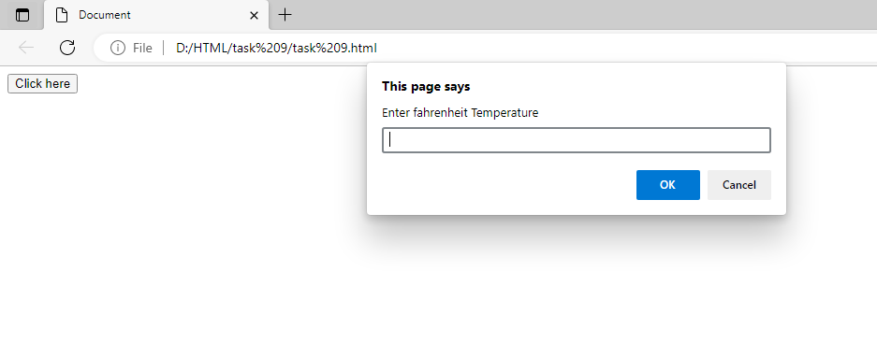

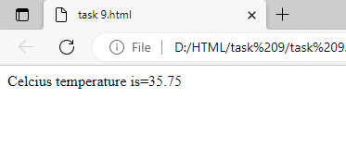

Task No#2: Take two inputs from the user using the prompt box. Ask the user to choose any one of the following operations.
- addition
- subtraction
- multiplication
- division

Solution:
<!DOCTYPE html>
<html lang="en">
<head>
<meta charset="UTF-8">
<meta http-equiv="X-UA-Compatible" content="IE=edge">
<meta name="viewport" content="width=device-width, initial-scale=1.0">
<title>Document</title>
<script>
function myfunction(){
var num1=parseFloat(prompt("Enter fisrt Number"));
var num2=parseFloat(prompt("Enter Second Number"));
var opt=prompt("Please Enter the operator +,-,/,*");
let result;
if(opt=="+")
{result=num1+num2;
document.write("Addition is="+result);
}
else if(opt=="-")
{result=num1-num2;
document.write("Substraction is="+ result);
}
else if(opt=="/")
{result=num1/num2;
document.write("Division is="+result);
}
else if(opt=="*")
{result=num1*num2;
document.write("Multiply is="+result); }}</script>
</head>
<body>
<input type="button" onclick="myfunction()" value="Click here">
</body></html>

